Butterfly programme **-** University College Zealand

**2025 March 24th to April 6th**

**Butterfly programme: Housing**

Housing can be a challenge in Denmark and especially finding suitable housing at a reasonable price/cost to meet a student budget. We have aimed to find a housing option to both balance the “quality”, a convenient location and taking into consideration the student budget (we don’t want to make participation too costly).

We are happy to inform that we now have secured housing in Roskilde Hostel called DanHostel Roskilde <https://m.danhostel.dk/no/hostel/danhostel-roskilde>

The hostel is located at the fjord of Roskilde in walking distance from Roskilde City Centre (approx. 10-15 min.) and Zealand Roskilde Campus (approx. 25 min.).

**Room specifications and price per night:**

Students will be accommodation in a shared room (5 persons in each room – same gender ONLY of course). Each room with own toilet and shower/bath. (see above sample picture)

Towels and bedding is included in the price. We further aim to have breakfast included as well.

The price per night per person will approx. be: DKK 370/EUR 50 (we just need to double check to be sure that we have breakfast included in the price – but +/-)

We have made an initial booking with arrival on Saturday 22 March and departure on Sunday 6 April (to be sure that the rooms are available upon arrival and departures).

Once we get a bit closer to the actual programme dates we will need to adjust arrival and departure dates to the actual travel dates.

Even though that Hostels in some countries do have a poor reputation this is not the case in Denmark - the place is relatively new, nice and clean.

**This is a picture of the Hostel itself:**

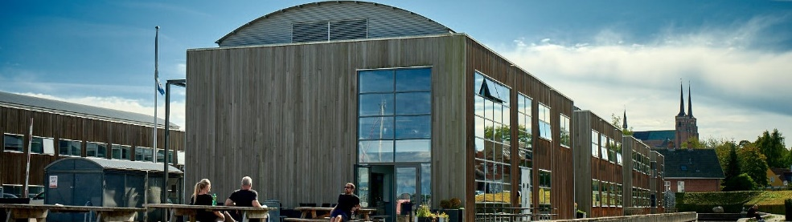

**Pictures of “sample” room with own toilet and bath:** 